Astra Vigil 2.0: Research and Architecture Report
Author: Niloy Bhattacharjee, Team MANTA, Sylhet, Bangladesh. Date: 28 October 2026.
Astra Vigil 2.0 is software that runs on one small computer inside a spacecraft, works with no internet, and compares each astronaut with their own normal so small changes are flagged early. This report is by Niloy Bhattacharjee, Team MANTA, Sylhet, Bangladesh, for the NASA Space Apps Challenge 2026. All data is simulated. It is not a medical device and NASA does not endorse it.

Summary
The short answers to the main questions are below. The details and the proof for each answer are in the sections after this one.
Question | Short answer
Which hardware does the software run on? | One small computer inside the spacecraft: a Raspberry Pi 5 (8 GB) or a Jetson Orin Nano. A normal laptop runs it today and is best for the demo.
Does it work offline? | Yes. The detector, the NASA records, the explanations and the console all run on the device. A headless-browser test saw only requests to localhost.
How is it different from today? | NASA ground teams watch crew health data, and at Mars a message takes up to 22 minutes one way. Astra Vigil adds a watcher on board that compares each person with their own normal and answers at once.
How accurate is it? | There is no honest single percent for real astronauts. On simulated data it caught 99.8% of planted 2-day HRV drops and 98.0% of planted 3-day multi-signal changes, but it also raised about 24 false alerts per 1,000 crew-days at the default setting.
Can it help on big missions? | It is built for them: offline, store-and-forward to Earth, and role-based privacy. It is not flight-qualified, and it supports human decisions. It does not make them.
Important: Astra Vigil flags a change. It never diagnoses and it never predicts an emergency. Every number in this report comes from simulated data, not from real astronauts.

Today versus Astra Vigil
Today, crew health on the International Space Station (ISS) is watched mostly from the ground. NASA's biomedical flight controllers are the main contact between Mission Control Houston and the crew's health care system. They watch environment data such as CO2 and oxygen in real time, and they downlink exam results, radiation doses and exercise data to ground medical teams. Flight surgeons work with them.
This works well near Earth. It gets harder far away. NASA's Mars planning paper says the one-way delay to Mars is up to 22 minutes, so crews will lean less on Mission Control. It says autonomy must let astronauts "monitor the state of their own health and wellbeing" and that decision support tools should help them decide without waiting for the ground.
Astra Vigil is one small piece of that need: an early-warning watcher that runs on board.
Question | Today on the ISS | With Astra Vigil
Who watches first? | Ground medical teams and flight surgeons in Mission Control | The crew member, on board. Ground gets only a status word.
What is watched? | Cabin air (CO2, oxygen), exam results, radiation doses, exercise data | Six daily body signals: heart rate, HRV, SpO2, sleep, core temperature, exercise
How fast is the answer? | Depends on the link. At Mars a message takes up to 22 minutes one way, so about 44 minutes there and back | At once, on the device, with no link
Does it need the ground? | Yes, Mission Control is the main support | No. It works offline.
A change is compared with what? | Not described in the sources we read | That person's own last 30 normal days
Who sees raw numbers? | Ground medical teams get downlinked data | Only the crew member. Others see less, and only with consent.
How much different will it be? We cannot give a percent. No study has compared Astra Vigil with current practice, and we will not make up a number. The differences we can show are about where the work happens (on board, not on the ground), how fast the first flag appears (no link delay) and who sees raw numbers (the crew member first).

How it helps astronauts and how it works
Astra Vigil helps in one way: it notices when a person drifts away from their own normal, while the change is still small. It does not say what is wrong. Here is a story with the simulated commander Kestrel, who is a fictional person.
- Wear. Kestrel wears a chest strap and a wrist device. Cabin sensors watch the air.
- Summarize. Each day the main computer turns the raw numbers into one row of six values.
- Learn. For the first days the status is "learning". The system needs at least 14 days to know Kestrel's normal.
- Notice. On days 250 and 251 of the simulated mission Kestrel's HRV falls far below normal. On day 251 Rule S raises an alert.
- Explain. The console shows plain text, for example "HRV is 2.6 SD below this crew member's own 30-day baseline. No diagnosis is made." It also lists saved NASA records on HRV in long spaceflight.
- Decide. Kestrel looks at sleep, workload and rest, and may talk to the medical officer. The software does not tell Kestrel what to do.
- Share less. The medical officer sees only "drifting toward worse", and only if Kestrel agreed. The commander sees the word "alert". Ground gets the same word later, after the delay.
Who | What they get | Why it helps
Crew member | Own values, own baseline, alerts and explanations | A private early warning, with no wait for the ground
Medical designee | Trend direction only, with consent | Knows who may need a check, without seeing raw data
Commander | A status word for every crew member | Sees crew readiness at a glance
Ground | The same status words, after the light-time delay | Stays informed without raw data crossing the link
The example uses simulated data. A real crew member's normal would be learned from their own real sensors, and that has not been tested.

Hardware: where the software runs
The whole program runs on one small computer inside the spacecraft. We name two good choices: a Raspberry Pi 5 with 8 GB of memory, or an NVIDIA Jetson Orin Nano. Both are small, use little power and need no internet. The sensors send data to this computer, and the computer shows the answer on a screen.
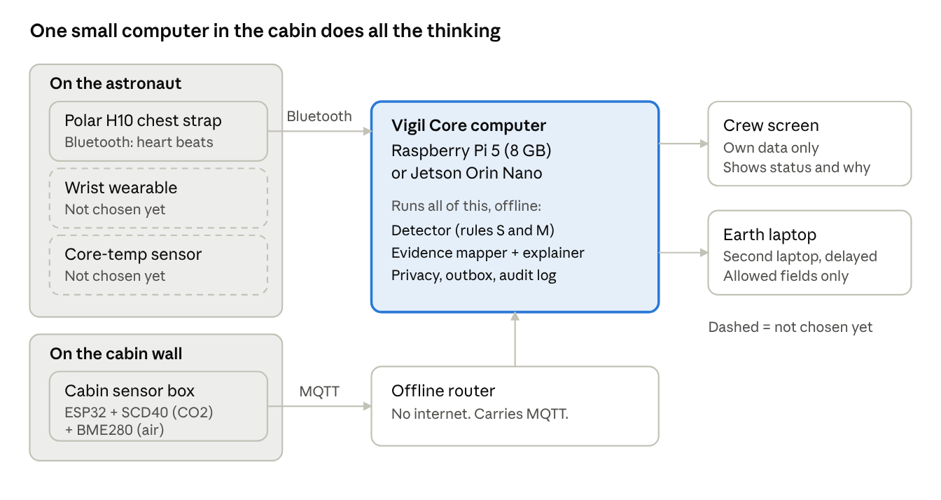
hardware layout · 1 main computer, 3 sensor groups, 2 outputs
Parts list
Part | What it is | Where it sits | Status
Main computer | Raspberry Pi 5 (8 GB) or Jetson Orin Nano. Runs the whole program. | Fixed box inside the spacecraft | Two options named
Chest strap | Polar H10. Sends heart beats by Bluetooth. | On the astronaut's chest | Chosen
Wrist wearable | Would add sleep and activity. | On the wrist | Not chosen yet
Core-temperature sensor | Would give body temperature. | On the body | Not chosen yet
Cabin sensor box | ESP32 board with SCD40 (CO2) and BME280 (air) sensors. Sends data over MQTT. | On a cabin wall | Chosen
Offline router | Small router with no internet. Carries the MQTT messages (Mosquitto). | Next to the main computer | Chosen
Crew screen | Shows the status and the reason. | In the cabin | Planned
Second laptop | Plays the role of Earth in tests. | Separate desk | Chosen for tests
These are test-bench parts. A real flight computer needs more design: two computers (A and B), error-correcting memory, and a read-only network link. That part is not built yet.

Software architecture
The program has three layers. Sense collects the numbers. Vigil Core thinks, and it all runs on board. Act shows the answer to people. No step needs the internet.
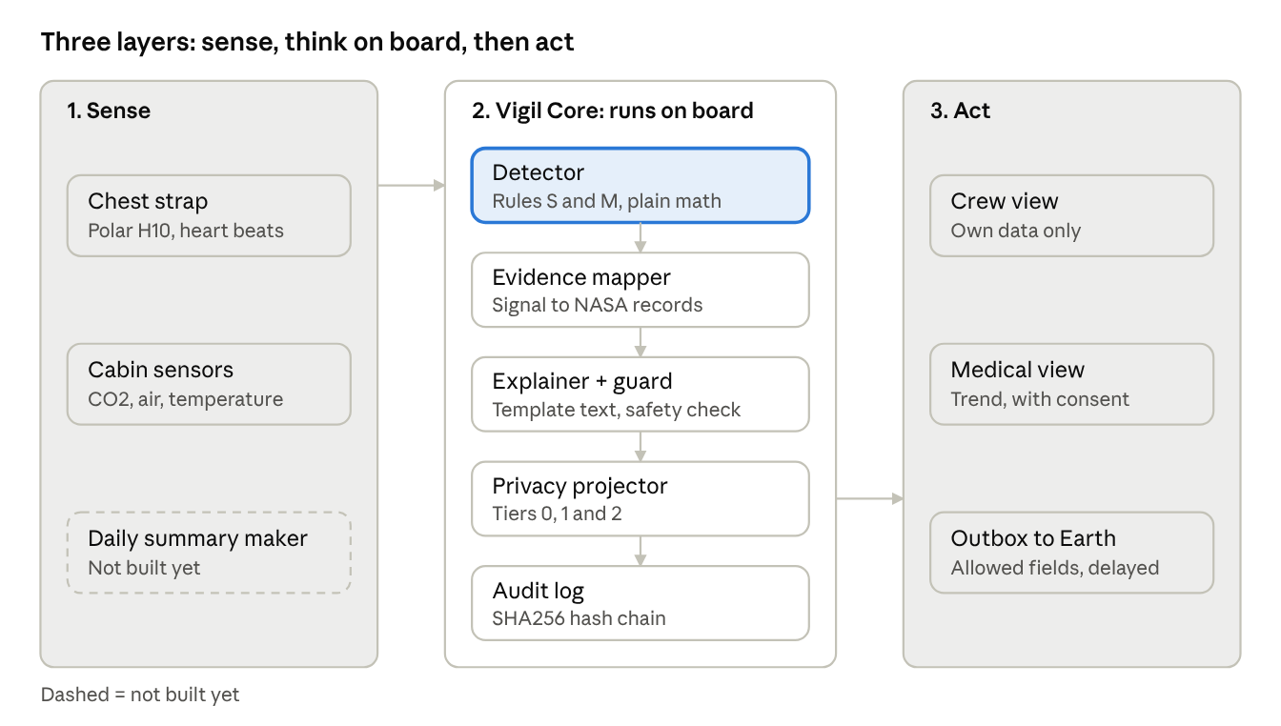
software architecture · 3 layers, 5 core modules
Each step in Vigil Core is a small module with one job. Data moves down the stack, and every access is written to the audit log.
Module (file) | Its one job
Detector (compute/detect.py) | Compares each day with the person's own normal and applies rules S and M. No AI.
Guard (compute/guard.py) | Blocks words that sound like a diagnosis.
Simulator (compute/fixture.py) | Makes a simulated crew with planted events for tests and demos.
Engine (engine.py) | Replays the mission day by day and keeps the status.
Evidence mapper (evidence.py) | Links an alert signal to saved NASA records, marked direct or adjacent.
Explainer (explain.py) | Writes the reason from a template. A local model may only reword it.
Privacy projector (privacy.py) | Decides what each role sees (tiers 0, 1 and 2) and checks consent.
Store (store.py) | One SQLite file for the audit chain, consent and the outbox.
NASA sync (nasa_sync.py) | Refreshes saved NASA records when a network exists.
Server (server.py) | REST and WebSocket server that also serves the console pages.
Privacy tiers. Tier 0 is the person's own data. Tier 1 adds trend direction for the medical role, only with consent. Tier 2 is the short status message that can leave for Earth.

Algorithm and blueprint
The detector asks one question: is this person doing worse than their own normal? It does not use a crowd average. It does not use AI.
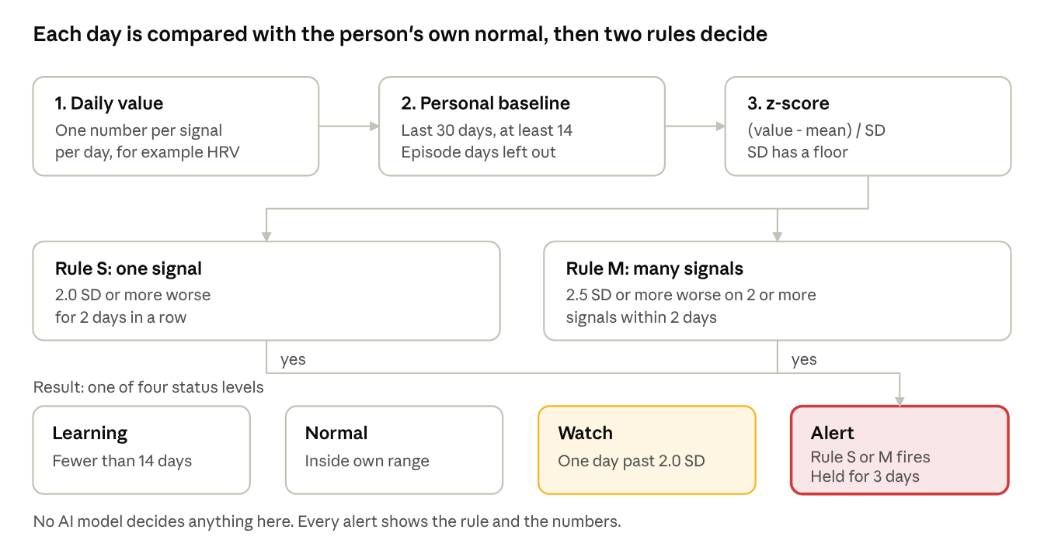
detector algorithm · 3 steps, 2 rules, 4 status levels
The steps
- Take the daily value for each signal, for example heart rate variability (HRV).
- Build the personal baseline from the last 30 days. At least 14 days are needed. Days that were already an episode are left out, so a slow slide is not learned as normal.
- Find the z-score. This counts how many standard deviations today is from the person's own mean.
- Set the direction. For some signals lower is worse (HRV). For others higher is worse. The sign is set so that worse is always clear.
- Apply the rules. Rule S looks at one signal. Rule M looks at many signals together.
- Pick the status: learning, normal, watch or alert. An alert is held for 3 days so it does not flicker.
The formula
z = (today - baseline mean) / max(baseline SD, SD floor)
The SD floor stops a very calm person from getting huge z-scores from tiny changes.
Settings
Setting | Value
Baseline window | Last 30 days
Minimum days before judging | 14
Rule S | 2.0 SD or more worse, 2 days in a row, one signal
Rule M | 2.5 SD or more worse, on 2 or more signals, within 2 days
Alert hold | 3 days
Episode days | Left out of the baseline
Worked example. A crew member's HRV baseline has a mean of 60 and an SD of 5.
Day | HRV | z-score | Result
1 | 48 | -2.4 | Watch (past 2.0 SD, first day)
2 | 47 | -2.6 | Alert (Rule S: 2 days in a row)
The alert shows the rule that fired, the numbers, and the NASA records that match the signal.
What happens in one step of the program. Each time new values arrive, the engine does these things in order:
- Read the new values.
- Update the baseline.
- Run the detector (rules S and M).
- Map the signal to saved NASA records.
- Write the reason from a template, then check it with the guard.
- Cut the message down for each role (privacy tiers).
- Queue the short status in the outbox, with the light-time delay.
- Write everything into the audit log.
Other small algorithms. The audit log links each entry to the one before it with SHA256, so any change is easy to spot. The test tool (Monte Carlo) makes simulated people with a noise pattern called AR(1), with a value of 0.3, and counts how often the detector finds planted events.

Offline operation
Everything that decides runs on the device, so a lost link to Earth changes nothing for the crew. Only two jobs need a network, and both are optional.
Part | Works offline? | How
Detector (Rule S, Rule M) | Yes | Plain Python and NumPy. No network and no AI model.
NASA evidence | Yes | 22 NASA records are saved on the device (retrieved 2026-10-20).
Explanations | Yes | A fixed template writes them. An optional local model can reword them, and the guard checks the result.
Console web page | Yes | Plain JavaScript. Scripts and fonts are bundled, with no CDN.
Privacy views, consent, audit log | Yes | One SQLite file on the device.
Link to Earth | Store and forward | The outbox keeps status words until a link exists, then sends them.
Refresh of NASA records | Needs a network | Optional. Tested only with mock responses.
A headless-browser test of the console saw requests to localhost only. The showcase website behaves the same: it makes no outside request until a visitor presses play on a video. The website's NASA API page is the one exception. Its server calls NASA only when a visitor presses Fetch, and with VIGIL_OFFLINE=1 it never calls NASA. Each answer is labeled live, cached or unavailable.

Accuracy: what we measured
There is no honest single "percent accurate" for real astronauts, because the detector has never seen real astronaut data. What we can give is a test on simulated data. We planted a known change, ran the detector 400 times and counted how often it raised an alert. We also ran it on 400 clean runs to count false alerts.
Result 1: the default setting, 400 runs of 600 days each.
Measure | Result
Planted 2-day HRV drop (3.5 SD) caught | 399 of 400 runs, 99.8%
Average delay for that drop | 0.98 day after it began
Planted 3-day change in HRV, heart rate and sleep (3.5 SD) caught | 392 of 400 runs, 98.0%
Average delay for that change | Same day
False alerts from Rule S (one signal) | 18.3 per 1,000 crew-days
False alerts from Rule M (many signals) | 5.66 per 1,000 crew-days
All false alerts | 23.96 per 1,000 crew-days, from 240,000 crew-days
24 false alerts per 1,000 crew-days is about 14 false alerts for one person over a 600-day mission. A planted event is rare, so in this test most alerts would be false alarms. That is the main weakness to fix before any real use.
Result 2: a check for this report, with stricter settings, 150 runs each. Raising the thresholds cuts false alerts a lot and costs only a little detection, until the threshold gets too high.
Setting (Rule S / Rule M threshold) | False alerts per 1,000 crew-days | False alerts per person in 600 days | 2-day HRV drop caught | 3-day change caught
Default (2.0 / 2.5 SD) | 24.1 | 14.5 | 99.3% | 100.0%
Stricter (2.5 / 3.0 SD) | 3.2 | 1.9 | 96.0% | 96.7%
Strictest (3.0 / 3.0 SD) | 0.8 | 0.5 | 42.0% | 96.0%
The stricter setting looks like the best balance in this test. It is not chosen yet, because the right threshold must come from real data.
What these numbers do not prove
- The data is simulated with a simple noise model (Gaussian, with a small day-to-day link). Real bodies are messier.
- The planted changes are large (3.5 SD) and have a clean shape. Real problems can be smaller or slower.
- Slow drifts are a known weak spot. Try the "Ramp" mode in the website playground to see it.
- The numbers describe this detector on this noise model. They say nothing yet about real astronauts, and they are not a medical accuracy.

Big missions: Moon and Mars
Astra Vigil cannot make a mission succeed by itself. It helps a crew look after its own health when the ground is too far to help quickly.
Mission | One-way delay to Earth | What Astra Vigil adds
ISS, low Earth orbit | Short | A second, private watcher next to the ground teams
Moon | About 1.3 seconds (Earth-Moon distance divided by the speed of light, our calculation) | The same, and it keeps working if the link drops
Mars | 3 to 22 minutes, per NASA | The first-line watcher. The crew cannot wait for an answer.
The Earth link in our code uses three Mars presets, 3.04, 12.51 and 22.29 minutes, taken from NASA delay-tolerant networking slides. At the far end a question and its answer take about 44.6 minutes.
How it helps a big mission
- It works alone. It is offline, so a lost link does not stop the watch.
- It sends news the safe way. The outbox keeps status words until a link exists. NASA describes delay-tolerant networking as a "store-and-forward approach" and says it finished its DTN project in January 2026. Our outbox is a simple queue. A flight design would use real DTN.
- It protects trust. On a long mission in a small crew, the crew member sees raw data first and others see less. This is the privacy tier design.
- It does the heavy work on board. In a press release (a vendor claim, not an independent result), HPE said its Spaceborne Computer-2 on the ISS processed DNA data in about six minutes instead of waiting about 12.2 hours to download it. That supports computing on board instead of on the ground.
- It is planned to survive faults (concept, not built). The flight idea uses two computers, error-correcting (ECC) memory and a read-only sensor network.
Which NASA-named risks the signals touch. The NASA Mars paper lists these risks. Astra Vigil watches body signals that may change. It does not measure the risk itself.
Risk named by NASA | Signal that may change | Status
Heart and blood pressure changes (fluid shifts) | Heart rate, HRV | In the detector
Isolation and behavior problems | Sleep, exercise (indirect) | In the detector
Bone and muscle loss (bone mineral density may fall about 1 to 1.5% per month) | Exercise minutes (indirect) | In the detector
Radiation (lifetime cancer death risk from about 15% to about 20% after a 1,000-day Mars trip) | Not a body signal. A space-weather feed (DONKI) is planned. | Not built
CO2 and dust | Cabin CO2 sensor | Hardware planned, not used by the detector yet

Datasets used
The project lists 25 datasets and sources: 9 NASA OSDR studies, 9 NASA NTRS reports, 4 research papers and 3 others. The Monte Carlo noise model in part D is a method that makes simulated data, so it is not counted in the 25. The 22 NASA and paper records were fetched from NASA's public search API and saved on the device on 2026-10-20. They give context for an alert. They are not proof that a rule is medically meaningful. A star (*) means the link is only "adjacent" (related), not the same topic.
A. NASA OSDR studies (SpaceX Inspiration4 mission, released 2024-05-14)
ID | Name | Linked signal
OSD-569 | Whole Blood Measurements from the SpaceX Inspiration4 Mission | SpO2*
OSD-570 | Inspiration4 PBMC Profiling | none (context)
OSD-571 | Inspiration4 Plasma Profiling | Core temperature*
OSD-572 | Inspiration4 Oral, Nasal and Skin Microbial Swabs | none (context)
OSD-573 | Inspiration4 Dragon Capsule Microbial Swabs | none (context)
OSD-574 | Inspiration4 Deltoid Skin and Microbiome Data | none (context)
OSD-575 | Inspiration4 Blood Serum Metabolic Panel and Immune/Cardiac Cytokine Arrays | HRV*, heart rate*
OSD-630 | Inspiration4 Stool Metagenome Profiling | none (context)
OSD-656 | Inspiration4 Urine Inflammation Panel | Core temperature*
B. NASA Technical Reports Server (NTRS) records
ID | Name | Year | Linked signal
NTRS-20040141628 | Individual peculiarities of adaptation to long-term space flights: 24-hour heart rhythm monitoring | 2000 | HRV, heart rate
NTRS-20050202025 | Real-Time Analysis of Electrocardiographic Data for Heart Rate Turbulence | 2005 | Heart rate*
NTRS-20220015090 | An Approach to Quantitative Risk Assessment for Combined Spaceflight Hazards: Evaluating the Impact of Short Sleep Durations on Space Crew Cardiovascular Health | 2022 | Sleep
NTRS-20190002002 | Sleep Environment Recommendations for Future Spaceflight Vehicles | 2016 | Sleep
NTRS-20240000934 | Temporal Changes in Astronauts' Muscle and Cardiorespiratory Physiology Before, During, and After Spaceflight | 2024 | SpO2, exercise, core temperature*
NTRS-20140003747 | Contributions of Astronauts Aerobic Exercise Intensity and Time on Change in VO2peak during Spaceflight | 2014 | Exercise
NTRS-20220019338 | Risk of Impaired Performance Due to Reduced Muscle Mass, Strength and Endurance, and Reduced Aerobic Capacity | 2023 | Exercise
NTRS-20150016966 | Evidence Report: Risk of Adverse Cognitive or Behavioral Conditions and Psychiatric Disorders | 2015 | Sleep*
NTRS-20230014307 | Enabling Model Organism and Commercial Astronaut Data Access Through the NASA OSDR | 2023 | none (context)
C. Research papers
ID | Name | Linked signal
DOI 10.1016/j.heliyon.2016.e00211 | Otsuka et al. (2016), Long-term exposure to space's microgravity alters the time structure of heart rate variability of astronauts, Heliyon | HRV
DOI 10.1038/s41598-021-94478-w | Otsuka et al. (2021), Circadian rhythms of heart rate, HRV and activity on long-term space missions, and sleep quality, Scientific Reports | HRV, heart rate, sleep
PMC3628896 | Adaptation of autonomic heart rate regulation in astronauts after spaceflight, Med Sci Monit (2013) | HRV*
DOI 10.1186/1472-6793-4-6 | Heart Rate Variability and Short Duration Spaceflight: Relationship to Post-Flight Orthostatic Intolerance, BMC Physiology (2004) | none (context)
D. Other data and sources
ID | Name | Status
SIM-CREW-600 | Simulated crew: 4 fictional astronauts (Kestrel, Lyra, Mira, Vega), 600 mission days each, six daily signals, with planted events. Made by Team MANTA. | Simulated. Every demo and test runs on it.
NTRS-20160011483 | NASA delay-tolerant networking slides, with Mars one-way light times (3.04, 12.51 and 22.29 minutes) | Numbers quoted in code
DONKI | NASA space-weather database (flares, geomagnetic storms, coronal mass ejections) | Planned. The cache is empty and the sync is tested only with mock responses.
Monte Carlo noise model | Gaussian AR(1) noise (phi = 0.3), seed 5000, 400 runs of 600 days. Made by tools/montecarlo.py. | Simulated. Used for the accuracy numbers.
E. Live NASA APIs on the showcase website (called by the server only when asked)
OSDR study search, OSDR dataset details, NASA Technical Reports Server (NTRS), DONKI space weather, EONET natural events, CMR (Earthdata collections), POWER (daily air temperature and humidity) and the NASA Image and Video Library. These were not tested against the real NASA servers. They are tested with mock responses only.

Technology and programming details
The stack is small on purpose, so a team can read all of it in an afternoon.
Part | What we use
Main language | Python 3.10 or newer
Web server | FastAPI (0.110 or newer) with Uvicorn (0.29 or newer)
Math | NumPy (1.26 or newer)
Storage | One SQLite file: audit chain, consent, outbox
Console | Plain JavaScript modules and HTML canvas. No framework, no CDN, no remote fonts.
Live updates | WebSocket, 10 updates per second. Replay speed 1 to 60 rows per second.
Explainer | A template always. An optional local model through Ollama, behind the guard.
Tests | pytest (8 or newer), httpx (0.27 or newer)
3D views (showcase website only) | Three.js r160, bundled, with shaders written in code and no downloaded textures
Fonts (showcase website) | Bricolage Grotesque, Instrument Sans, Noto Sans Bengali, all SIL OFL, bundled
License | Apache-2.0 for the code
Coding rules we follow
- No AI model decides anything. The detector is plain math, and every alert carries the rule that fired and the numbers behind it.
- The same input always gives the same output. Demo data is seeded, so any day can be rebuilt.
- The explainer writes from a template first. A model may only reword it, and the guard throws away diagnosis words.
- The outbox only sends fields on an allow-list.
- Every access is written to a hash-chained audit log.
- Every input is checked for type and range before use.
Console project layout
astra-vigil/
run.py launcher
backend/astra/
compute/detect.py rules S and M (no model)
compute/guard.py diagnostic-language guard
compute/fixture.py simulated crew, planted events
engine.py mission replay state machine
privacy.py roles, tiers, projection
store.py audit chain, consent, outbox
evidence.py signal to NASA record mapper
explain.py template + optional local model
nasa_sync.py OSDR, NTRS, DONKI clients
server.py REST + WebSocket + static
web/ console (canvas, ES modules)
data/ cached NASA records
demo_fixtures/ simulated crew data
tests/ 33 tests
Console API
Method | Path | What it does
GET | /api/state | Snapshot of the mission, filtered by role
GET | /api/crew/{id}/series | Chart data for one crew member (tier 0 only)
GET | /api/crew/{id}/trend | Trend direction, with consent (tier 1)
POST | /api/control | Play, pause, speed, jump to a day, next alert
POST | /api/link | Set the modeled light-time delay
POST | /api/consent | Grant or withdraw consent
GET | /api/evidence | NASA records for an alert
GET | /api/audit | Audit log tail and chain check
GET | /api/outbox | Queued and delivered status messages
GET | /api/nasa | Saved NASA catalogue
POST | /api/nasa/sync | Refresh the saved records when a network exists
GET | /api/validation | Live score against the planted events
WS | /ws | Live updates and alerts
Showcase website (second project). It reuses the same detector so every demo is real output. It has about 1,400 lines of Python and about 2,700 lines of JavaScript, a NASA API page with 8 APIs, and 850 passing test cases. The text is kept in matching English and Bangla files, and the tests fail if the two differ in shape. The console project has 33 automated tests.
To run it: install the requirements with pip install -r requirements.txt, then start it with python run.py --open. To let a tablet on the same offline router open the page, start it with --host set to the computer's local address, and keep that network closed to the internet.

Limits and next steps
This report tries to be honest. Here is what is not done yet.
What we have not proven
- No real-data accuracy. All accuracy numbers come from simulated people. No flight or ground study has tested the detector on real astronauts.
- False alarms. At the default settings the detector gave about 14 false alerts per person over 600 days in simulation. A stricter setting lowers this but misses more real events (see the tradeoff table in the Accuracy section).
- Nothing tested on real flight hardware. The software has run on ordinary laptops only. We have not tested it on a Raspberry Pi 5 or Jetson in a radiation or vibration setting.
- NASA live links not tested on real servers. The saved NASA records work offline. The refresh step needs a network and has not been run against the live servers.
What is not built yet
Missing part | Why it matters
Sensor bridge | Reads the chest strap and cabin sensors and feeds the detector
Daily summary maker | Turns raw beats and readings into one number per day
Cabin data in the detector | CO2, temperature and humidity are shown but not yet used in decisions
Core-temperature sensor | A device is not chosen yet
Wrist wearable | A device is not chosen yet
Flight design | Two computers (A/B), error-correcting memory, read-only network, store-and-forward messages
Next steps, in order
- Build the sensor bridge and daily summary maker, and test them with a Polar H10 on volunteers.
- Run the detector on a public ground study (bed rest or isolation) to get a first real-data score.
- Tune the thresholds with the false-alarm tradeoff in mind.
- Test on a Raspberry Pi 5 with a closed offline router.
- Ask a flight surgeon or space medicine team to review the alert wording and the privacy tiers.
This is a decision-support tool. It does not diagnose and it should never replace a doctor.

Team and sources
Author: Niloy Bhattacharjee, cyber-security student, Sylhet, Bangladesh.
Team: MANTA, Sylhet. NASA Space Apps Challenge 2026.
Project: Astra Vigil 2.0.
License: Apache-2.0 for the code. NASA data stays NASA's and is used under NASA's own terms.
Sources
- NASA Biomedical Flight Controllers (BME)
- NASA: Human Health and Performance for Mars (PDF)
- NASA: Delay/Disruption Tolerant Networking
- HPE press release: Spaceborne Computer-2 experiments (vendor claim)
- NASA NTRS 20160011483
- NASA Open Science Data Repository (OSDR)
- NASA Technical Reports Server (NTRS)

